

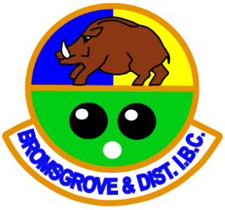
Austin Road, Charford, Bromsgrove, B60 3PT
Tel: 01527 577226

A Guide for New Bowlers
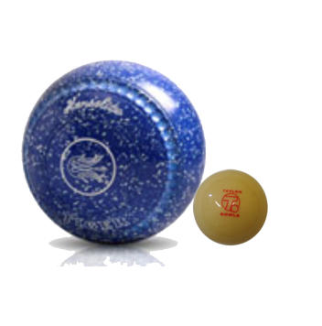

Introduction

A warm welcome to Bromsgrove and District Indoor Bowls Club and the game of bowls. It’s a great game and we all hope you enjoy the learning experience.

This guide should be read in conjunction with the club’s members handbook. The handbook includes details of social and competitive bowling opportunities, dress code, club opening times and the structures and general operation of the club.

The game of bowls is relatively simple and most players will get the hang of it fairly quickly but it is important that you understand the basic rules and etiquette. The rules are designed to ensure that everyone has a common understanding of how the game should be played. The etiquette is for the most part good manners. Following them will ensure that the game is played at the right pace and players on your rink and adjoining rinks won’t be disturbed.

Alongside this guide please take the time to read the laws of the game. These can be borrowed from reception.

Coaching

As a new bowler you will be offered a minimum of 4 x 2 hourly sessions with one of our coaches, after which you will be invited to join and play with other members on the green. There is a rink fee for each person for the first 4 lessons but our coaches do not charge for these initial sessions.

The club requires that you do not train or play without a coach being present until you complete these sessions. The hiring of bowls and shoes can be made at reception if required.

After your initial training period your coach may recall you after approximately 3 months for a one off 2 hour training session to make sure that your techniques are improving and you are not picking up any bad habits.

If after this session you feel you require extra coaching with your approach, stance, delivery or consistency, please feel free to contact any of the club coaches (there will almost certainly be a charge for their time).

Coaching sessions can be arranged through our coaching facilitator Jayne Sippitts
Tel:07769 359486 or 01527 523383

Don’t forget, we were all beginners once.

The Basics

The object of the game
The object of the game is to roll your bowls so that they will come to rest as close as possible to the jack. The side that has their bowl nearest the jack scores one point for that bowl, and an additional point for each bowl that it has nearer the jack than the nearest bowl of the opposition.

Why does the bowl curve as it rolls?
A bowl curves because of the way that it is made – not because of the way it is delivered by the bowler. The bowl is not uniformly shaped and since this makes it heavier on one side, it naturally curves in the direction of that side as it loses speed. This is called the ‘bias’ and is identified by the smaller of the rings found on each side of the bowl.

How Long Does a Game Last?
Cricket has innings, tennis has sets, bowls has ends. When all players on both sides have delivered their bowls in one direction on the green, this completes one end. The duration of a game can be measured in three different ways dependent upon the type of game and local rules.
- A game may consist of a pre-determined number of ends; or
- Can be concluded at the end of a pre-determined time limit; or
- Can be concluded when one team or player reaches a pre-determined number of shots.
Ensure that you always know the specific rules relating to the game you are playing.

How are the bowls identified?
There are many different makes and colours of bowls and each set of bowls has different markings for easy identification. If you have a responsibility at the head, please make sure you can distinguish between your team’s bowls and your opponents’.

Types of game
Bowls is normally played as:

Singles – played between two contending players, each playing four bowls of a set singly and in turn.

Pairs – played by two contending teams, each of two players, each playing four bowls of a set, who shall play singly and in turn.

Triples - played by two contending teams, each of three players, each playing three bowls of a set, who shall play singly and in turn.

Fours/Rinks - played by two contending teams, each of four players, each playing two bowls of a set, who shall play singly and in turn.

NB – These are the standard formats but there are variations. For example there is a two wood singles game, at the World Indoor Championships they have a three wood pairs competition and there is an Australian version of pairs where players take it in turns to bowl the last bowl. Again, please be sure of the rules relating to the competition you are playing in.

Improving your game
There are a number of single page aide memoires available, covering a variety of topics to help improve your understanding and playing of the game.

Choosing and delivering your bowls

Choosing your bowls
The most expensive and important purchase you will make when starting bowling is a set of four bowls. Do not rush into it and listen to advice from your coach.

Bowls come in a variety of sizes, weights and colours. Choose a set that are comfortable for you to hold and bowl. There is a variety of manufacturers who each produce a range of different bowls with subtly different characteristics in the line that they take. Some turn more than others and some turn in a smooth arc whilst others turn more sharply as they slow down.

Delivering your bowls
There is no such thing as an ideal delivery. The important thing is that it should be consistent for the sake of accuracy.

It is recommended that you stand with both feet parallel on the mat, slightly apart, facing the line along which you intend to send the bowl. Eyes should be looking down the delivery line or at a point on that line. Bend the knees so at the point of release, the bowl is close to the bowling surface.

The bowling hand should be brought forward parallel with the body throughout.

Etiquette
Etiquette in bowls is for the most part common sense and good manners. Following good etiquette will not only make the game more enjoyable for everyone, it will also ensure the game is played at a good pace. When bowling always try to follow these simple guidelines.

- Dress correctly;
- Shake hand with your opponents before and after the game;
- Stand still and stay behind the head or mat when others are about to bowl;
- Do not distract when a player is about to bowl;
- When your bowl comes to rest the rink passes to your opponent;
- Do not criticise, only praise;
- Keep to your own rink do not wander, walk down the centre of the rink when the last bowl comes to rest;
- Unless you have been delegated to decide the shots at completion of an end, do not interfere with the process;
- Pay attention to the game at all times and encourage your team;
- Stand well back from the head when firing shots are played;
- If you have to walk along the ends or sides of the green, be aware of bowlers on other rinks; and
- Enjoy the game, whether winning or losing.

We hope you have found this guide helpful and that it gives you some food for thought. Bowls is a great game from both a social and competitive perspective. Enjoy your bowling and if you have any questions please do ask.

Bromsgove and District Indoor Bowls Club
Management Committee

NOTES

